DIS-EUR-Vinca male figurine with trousers-4500 B.C.E.-15,1 cm

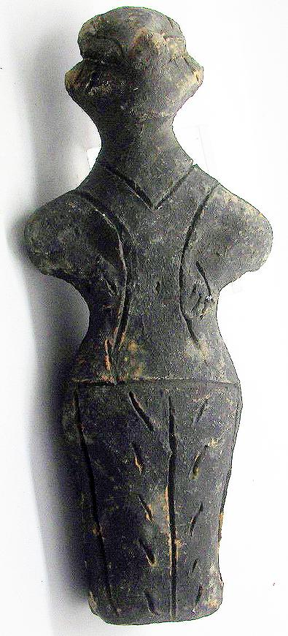 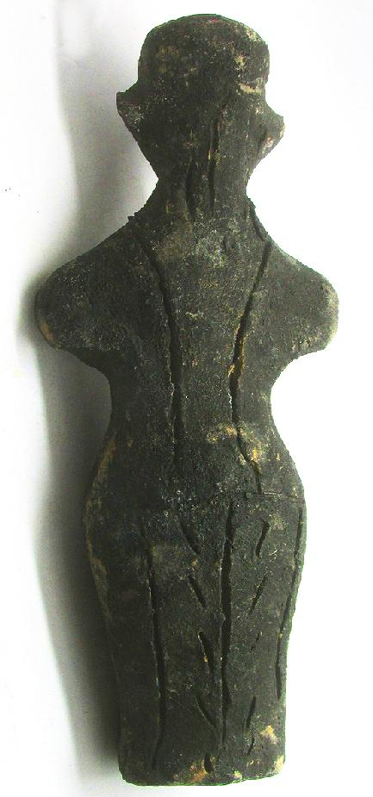

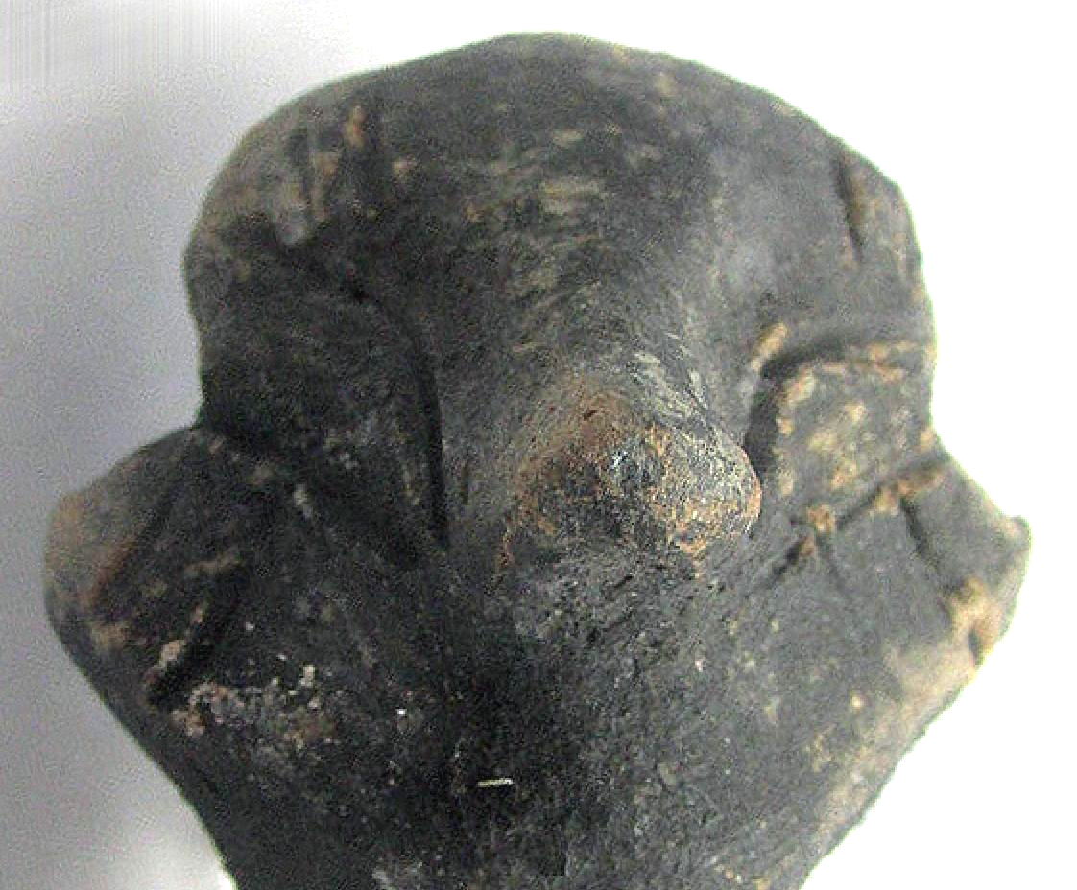

Formal Label: Vinca Neolithic ceramic male figurine, ca. 4500 BCE-15.1 cm

Accession Number: GN778.32.A4

Date or Time Horizon: ca. 4500 BCE

Geographical Area: Balkans

Cultural Affiliation: Vinca

Medium: Fired clay

Dimensions: H 15.1 cm

Weight:

Condition: Excellent

Provenance: Michael Davies 2 hanover court Didcot Oxfordshire ox11 8nu United Kingdom

**References:**

**Discussion: Intricate diamond and chevron pattern incised in skirt area**

Sold by [mikes-artefacts](http://myworld.ebay.com/mikes-artefacts) ( [546](http://feedback.ebay.com/ws/eBayISAPI.dll?ViewFeedback&userid=mikes-artefacts) )

### Delivery package 1 of 1

Estimated delivery Friday, Jan 22, 2016 - Friday, Jan 29, 2016